JUnit Testing Exercises

**Exercise 1: Setting Up JUnit**

**Scenario :**

You need to set up JUnit in your Java project to start writing unit tests.

Steps: 1. Create a new Java project in your IDE (e.g., IntelliJ IDEA, Eclipse).

2. Add JUnit dependency to your project. If you are using Maven, add the following to your pom.xml: junit junit 4.13.2 test.

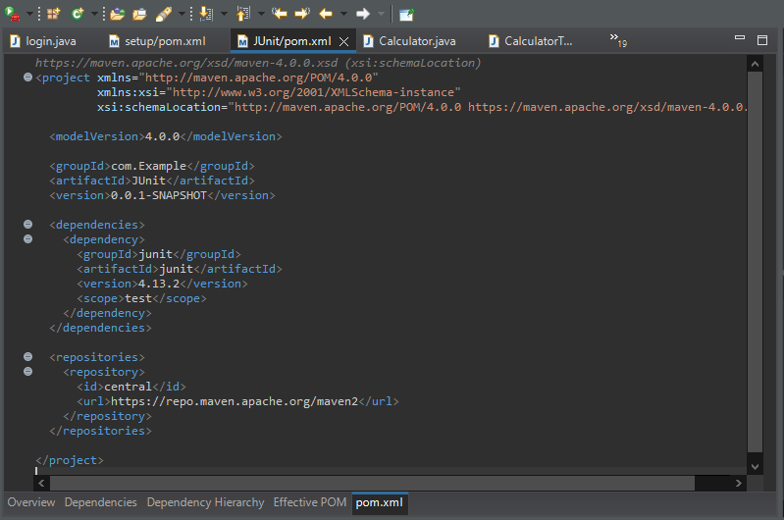

3. Create a new test class in your project.

**Calculator.java:**

package com.example;

public class Calculator {

public int add(int a, int b) {

return a+b;

}

}

**CalculatorTest.java:**

package com.example;

import org.junit.Test;

import static org.junit.Assert.*;

public class CalculatorTest {

*@Test*

public void testAdd() {

Calculator calc = new Calculator();

int result = calc.add(120, 500);

System.*out*.println("Sum is: " + result;

*assertEquals*(620, result);

}

}

**OUTPUT:**

